Dashboard
- Sales graph not required
- Unpaid vendor bill not required
- In search bar I should be able to search box and packet

Inventory
- Club inventory, box and packet together
- In assign items the interface is confusing. Option required for multiple items to scan at once
- QR Codes – Option to reprint qr for pieces is not required but give the option to download excel file of the stored qr for pieces which can be sorted through box, packet, category wise
- Bulk import
- Where are the unpacked items or unassigned items list.
- Today I have uploaded bulk import, without entering the packet value, as I can see the products has by default set to PKT-01
- When I am into a particular product while moving give the option to scan the box
0

Movement
- Club karigar in and out together and do the same for hallmarking as well.
- Counter to tray option is not working
- In the “send to counter” give option to select the product on counter to return directly from the pending bar. I mean after clicking I can either see the details and bring it back just by clicking. Give option to scan multiple boxes. If anything is sold in the box give the status there.
- Remove return to vault option, put it in a single screen. Just to vault to counter page show how many boxes are out and by which user “STILL ON COUNTER”.
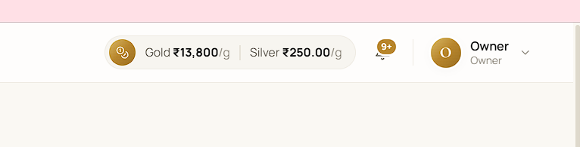
In this notification bar, set the notification on the products which are out of the vault be it anywhere counter, display or any other reason
- Give option to delete empty boxes, packets
- Change “Assign Item” as “Change Item location”
- Karigar what I can see. Timeline for expected back give the option for today as well
- Karigar, give the number of destined to be made by the karigar, details for those item to be filled later, multiple category of items are created in a batch
- After the item is returned from Hallmarking give option to upload multiple HUID and edit the existing weight of the selected products, here the overall weight of the batch may change.
- Keep the unpacked items batch wise as the date of upload, the data can be changed at any moment.
- Items given for hallmarking will be untagged, as it will be uncessary for us to tag un huid items and then tag the same items. Therefore for hallmarking dispatch keep option to tell the number of products to be HUID.
- After items are brought back from Hallmarking give a option to download the existing data excel and reupload the same with the other left over data like huid or making charges.
- For photography items to be sent box, packet or piece wise.
- For exchange the status tracker is useful, see every process will take time therefore give the option to continue from the last step. I cant continue from the exchange I left incomplete
- In the preset rate of deduction, give the option at the rate change page. The deductions will be based on carat and metal.

Custom Order
- New order give option to upload reference images. Simplify it, create/select cutomer, enter details of product + reference image if any, advance paid.
- Status board is good. Going to karigar dispatch page, show the orders pending so that I can add that item in a particular order batch.

Pricing & Rate
- Show me the making charges for product category wise, I may be able to assign making charges if undone or set new rate category or product wise.
- Same for discount, discount will be on same principal % wise, gm wise or piece wise.
- Give me option to add additional charge on selected product, category of product and so on.
hl

Sales
- I have seen if I scan any random item for sales it takes the entry without considering that the box is still in the vault. If the staff forgets to move it out of vault then?. Here you can add a layer that the product is not out. Staff scans and give the option to move it out of vault to counter.
- For sales give the status bar like the exchange one. It will be easy for my staff
- Give option to enter referral code

Purchase
- In purchase its okay to give reference bill no but financial details are not required.
- While purchasing also if I purchase ready made product give option to mention the number of products and status whether hallmarked / HUID or not. If I mention 20 items I should be able to upload the unfilled data product wise or download blank template for 20 items and reupload the same.

Accounting
- Give me ledger in download pdf option or excel for karigar, hallmarking center. No financial details required.
- Tally export not required

Loyalty
- This is referral code, information required is that against this particular refereal code how may gms of metal has been purchased
- No need to issue default referral code to all customers, only those who are willing to participate only for them the code will be issued. Also a particular persons refereal code cannot be used against purchases against him
- Bring our referral from administration to loyalty or give the entire heading name as referral only

Monthly Scheme
- Give me option to add existing with number of months already paid and how much is pending
- Show how many months paid and pending
- Show the date of completion

Audit
- It means I am rechecking my stock for audit I can take a box and check whether all updated or not. This is also a status, like last audited and so.

